Practical - 5
Aim: - Web application testing using DVWA
Introduction to DVWA: -
- Damn Vulnerable Web App (DVWA) is a PHP/MySQL web application that is damn vulnerable.
- Its main goals are to be an aid for security professionals to test their skills and tools in a legal environment, help web developers better understand the processes of securing web applications and aid teachers/students to teach/learn web application security in a class room environment.

Command Execution: -
- Command Execution is where a website application provides the ability to execute system commands.

Command Injection Attack: -
- The purpose of the command injection attack is to inject and execute commands specified by the attacker in the vulnerable application.
- In situations like this, the application, which executes unwanted system commands, is like a pseudo system shell, and the attacker may use it as an authorized system user.
- Note, the commands are executed with the same privileges as the application and/or web server.
- Command injection attacks are possible in most cases because of lack of correct input data validation, which can be manipulated by the attacker (forms, cookies, HTTP headers etc.).
Command Injection Harvesting?
- Command Injection Harvesting is where a malicious user manipulates a website command execution application to render sensitive data. (E.g., usernames, config files, directory and file listings, etc).
- Unix/Linux Example: 9.9.9.9; cat /etc/passwd
- Windows Example: 9.9.9.9 && dir

Using DVWA for Web Application testing: -
Step-1 : Open DVWA in web browser and configure it.
- Go to http://192.168.1.106/dvwa/login.php and enter user name and password as below:
Username: admin Password: password
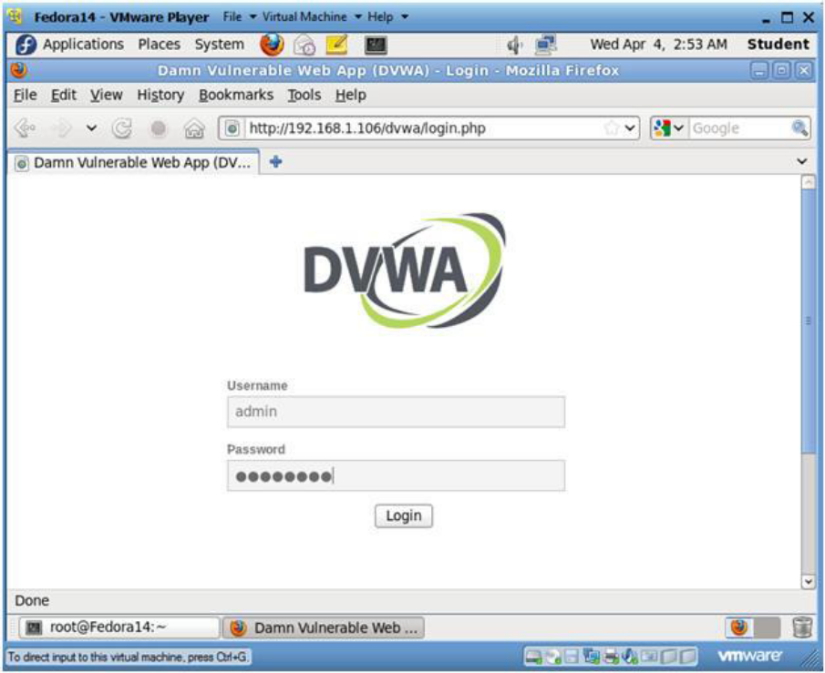

Step-2: Set Website Security Level (Part 1)

Click on DVWA Security

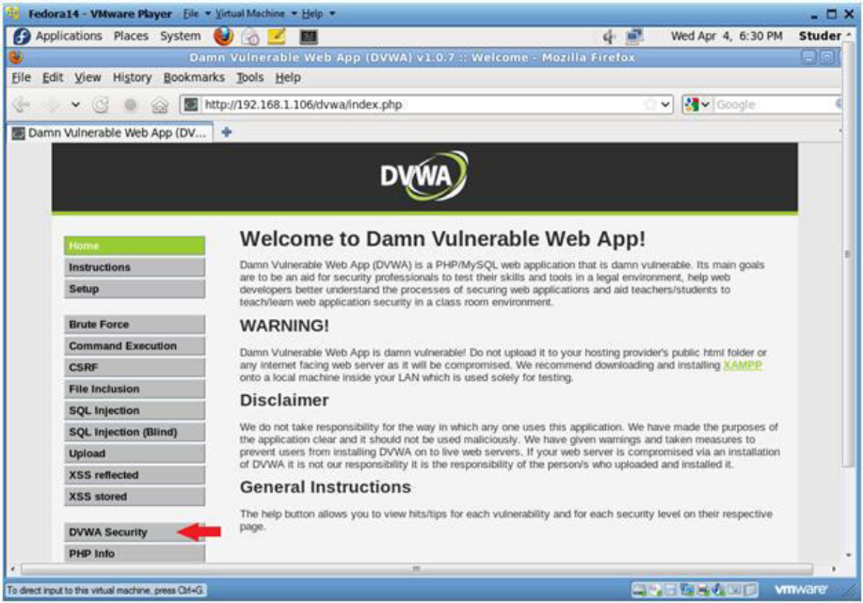

Step-3: Set Website Security Level (Part 2)

Select Low
Click Submit

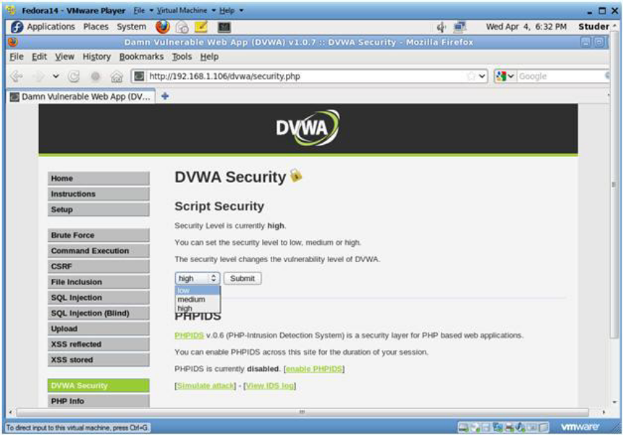

Step-4: Perform different vulnerability tests
- Command Execution
Click on Command Execution

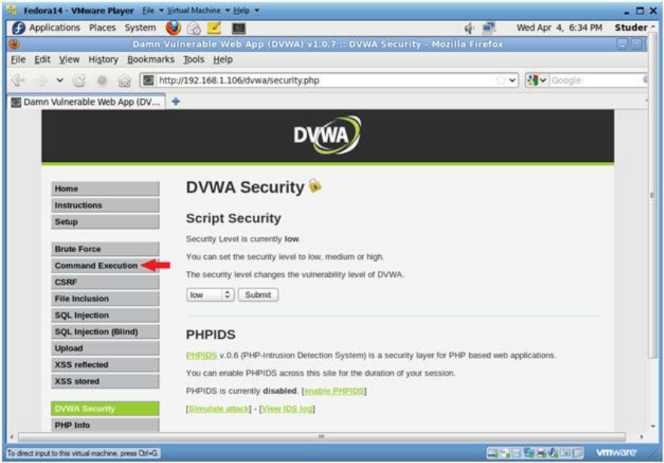

- Execute Ping

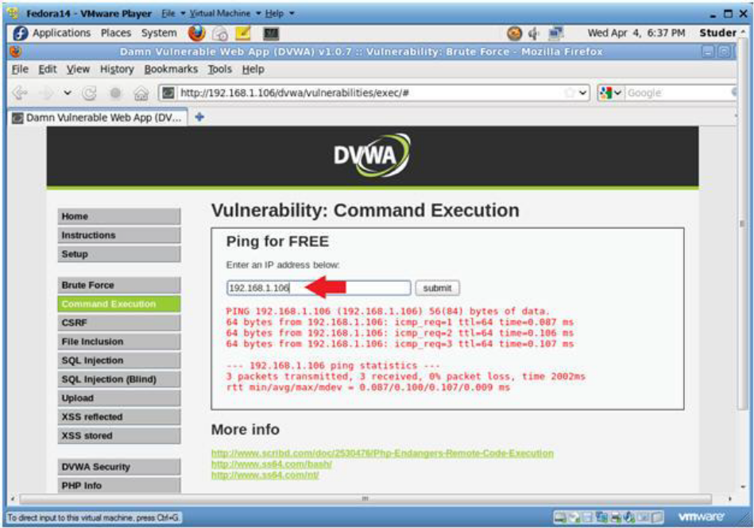

- cat /etc/password (Attempt 1)
cat /etc/passwd
Click Submit
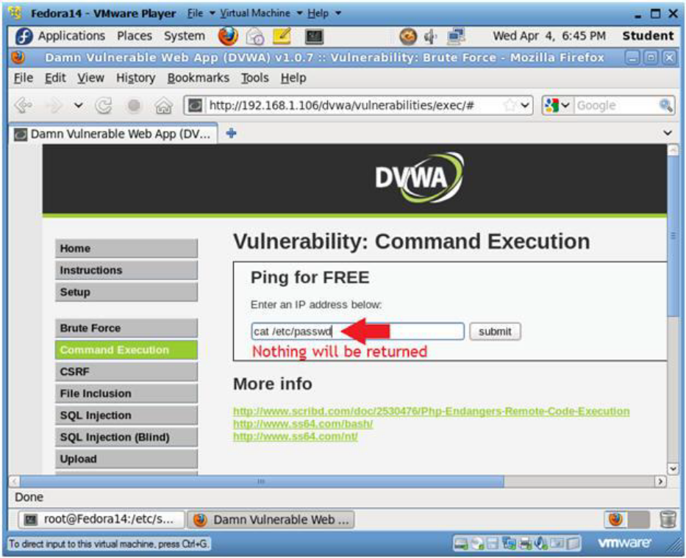
- at /etc/password (Attempt 2)

